**Guide to Hamsphire CSI Code**

**Trigger: xhants_auto_acknowledged**

Fired:

New PEM with status of E','P','T','F','S','L','W','EX','PX','TX','FX','SX','LX','WX' and category of ‘HDEF’

Effect:

PEM ID placed in XHANTS_AUTO_ACK_Table. DBMS_JOB runs every 2 seconds polling for records in this table and running xhants_pem_bespoke.auto_acknowledge_status .

**Trigger: xhants_auto_acknowledged_api**

Fired:

As above but on update when PEM changes from a status of ‘U’ and flagged as created from Locator. Will not be relevant until locator is in use.

Effect:

PEM ID placed in XHANTS_AUTO_ACK_Table. DBMS_JOB runs every 2 seconds polling for records in this table and running xhants_pem_bespoke.auto_acknowledge_status .

**Procedure: xhants_pem_bespoke.auto_acknowledge_status**

Puts all PEMs from XHANTS_AUTO_ACK table into a cursor and processes any records which are not locked. The process determines the status to set the PEM ‘AK – Acknowledged’ or ‘AR – Acknowledgment Required’. It also sets the email address to one of the operating areas North, East, South, West if the enquirer has not supplied an email address. This is called by a dbms_job that is run every 2 seconds.

**Trigger: xhants_pem_bespoke_trg**

Fired:

Updated PEM has new status of ‘AK’, the category must be HDEF.

Effect:

The acknowledgement date is set to the current sysdate.

**Trigger: xhants_ack_mail**

This trigger performs 3 distinct functions listed below.

**Email for change of responsible user:**

Each time the responsible user is changed for any PEM, an email is sent to that user. References *xhants_pem_bespoke.mail_new_resp*

**Customer and 3rd Party Emails:**

All emails to customers and 3rd parties are triggered here. List below of status which causes the fire, and the relevant procedure called to create the email.

|  |  |  |
| --- | --- | --- |
| **New PEM Status** | **PEM Source** | **Procedure Called to create Mail** |
| CTP | All | xhants_pem_bespoke.mail_poss_recharge |
| OLG | All | xhants_pem_bespoke.mail_new_ext_resp |
| EX | ALL | xhants_pem_bespoke.mail_3rd_party |
| EX | All (Resp user has to be a contact) | xhants_pem_bespoke.mail_inform_3rd |
| OLG | All | xhants_pem_bespoke.mail_olg_3rd_party |
| UEX | All | xhants_pem_bespoke.mail_unknown_3rd_party |
| MG | 'F','S','L','W','E','P','T' | xhants_pem_bespoke.mail_maint_gang |
| MS | 'F','S','L','W','E','P','T' | xhants_pem_bespoke.mail_made_safe |
| PW | 'F','S','L','W','E','P','T' | xhants_pem_bespoke.mail_planned_work |
| NM | 'F','S','L','W','E','P','T' | xhants_pem_bespoke.mail_no_work_reqd |
| ND | 'F','S','L','W','E','P','T' | xhants_pem_bespoke.mail_no_def_found |
| PC | 'F','S','L','W','E','P','T' | xhants_pem_bespoke.mail_passed_contractor |

There is little point in detailing all of the mail procedures above. The main difference for all of them is content. It should be noted that all of these packages create the email needed using the standard “nm3mail” package, and the emails are placed in a queue and sent every 10 minutes using the dbms_job that already exists in the system to do this.

It is important to bear in mind that the nm3mail package does not cater for email addresses not attributed to a user in the system. Function xhants_pem_bespoke.get_mail_recipient gets around this by forcing the public email addresses into NM3_MAIL_USERS table. All the mail procedure above call this function by supplying name and email address, and the function will supply the correct NMU_ID to identify the email address to send the email to.

**Setting PEM as Complete:**

The following statuses 'UEX','OLG','TP','ND','NM','CA','WC','EX' with a category of ‘HDEF’ will put them PEM_ID into XHANTS_PEM_AUTO_CLOSE. Records entered into this table will set the PEM to CO – Complete. A dbms_job runs every 2 seconds polling the table using xhants_pem_bespoke.auto_close_pem to close.

**Trigger: XHANTS_WO_STATUS**

Fired:

Work order line has status of QUERIED.

Effect:

Runs xhants_pem_bespoke.mail_queried_wo. This sends an email back to the WO originator to say the WO has been queried.

**Trigger: XHANTS_DEFECTS**

Fired:

Defect Status Code is changed

Effect:

Depending on the type of defect status, it will look for any linked PEM’s and based in hants business rules will set status of the PEM, based on the new status of the defect.

**Trigger: XHANTS_DEF_PEM_LINK**

Fired:

PEM is linked to a defect.

Effect:

PEMS linked to an existing defect will set the PEM status based on the defect status it is linked to.

**A core package has been changed in order for NM3MAIL to work properly. The rules stopping emails being sent via a subordinate user where the sender id is not them has been commented out. On your next upgrade this amended package will need to be re-applied.**

**Business Flow for xhants_pem_bespoke.auto_acknowledge_status** 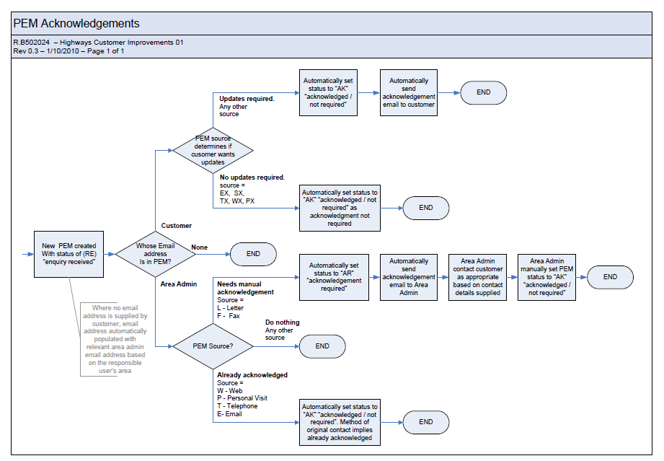

EM Numbers below linked to actual code called.

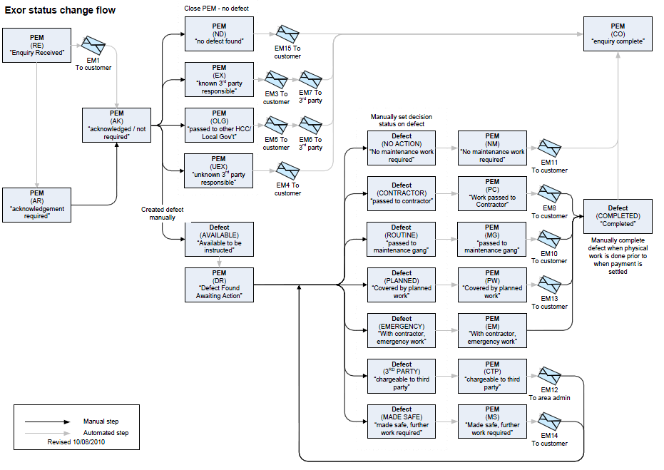

EM1 > xhants_pem_bespoke.mail_auto_ack

EM3 > xhants_pem_bespoke.mail_3rd_party

EM4 > xhants_pem_bespoke.mail_unknown_3rd_party

EM5 > xhants_pem_bespoke.mail_3rd_party

EM6 > xhants_pem_bespoke.mail_olg_3rd_party

EM7 > xhants_pem_bespoke.mail_inform_3rd

EM8 > xhants_pem_bespoke.mail_passed_contractor

EM10 > xhants_pem_bespoke.mail_maint_gang

EM11 > xhants_pem_bespoke.mail_no_work_reqd

EM12 > xhants_pem_bespoke.mail_poss_recharge

EM13 > xhants_pem_bespoke.mail_planned_work

EM14 > xhants_pem_bespoke.mail_made_safe

EM15 > xhants_pem_bespoke.mail_no_def_found